**BEEE EXPERIMENTS LAB FILE**

Experiment 7: Designing a programmable digital data display system.

Circuit diagram:

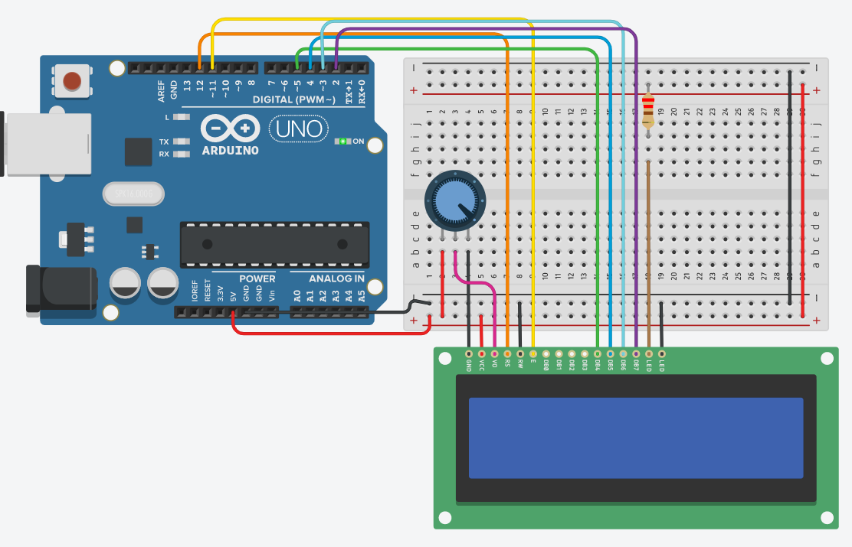

**THEORY**

**CONCEPTS USED:**

1. ***LCD:***   
   LCD (Liquid Crystal Display) is a type of flat panel display which uses liquid crystals in its primary form of operation. LEDs have a large and varying set of use cases for consumers and businesses, as they can be commonly found in smart phones, televisions, computer monitors and instrument panels.
2. Use of DATA BUSES.
3. Uses of Arduino.
4. Connection LCD to ARDUINO board.
5. The use of a variable resistor.
6. Using pre defined libraries in coding(liquidcrystal.h)

**LEARNING AND OBSERVATIONS:**

**PROBLEMS AND TROUBLESHOOTING:**

1. Improper connection to the power pin was made and it was solved after making proper connection.
2. The proper port of the Arduino was not selected. After it was selected the Arduino worked perfectly.
3. The code had some errors like proper pin was not mentioned, etc. But after modifying the code, everything worked perfectly fine.

**PRECAUTIONS:**

1. Faulty code will lead to the LCD not blinking.
2. Make sure the connections are appropriate.
3. The use of brackets and pinMode needs to be correct otherwise the code won't work.
4. Wrong declaration of LED pins will lead to wrong functioning.

**LEARNING OUTCOMES:**

1. I learnt about the practical usage of LCD
2. Practical use of DATA BUSES.
3. Now I have enhanced and improved knowledge of breadboard connections.
4. Advantages of Programmable LCD'S.